Setting up Kali Linux in Docker on Windows 10

A few times now, I find myself wondering why I need a full blown VM. I ~~like~~ need to quickly get my tools up and running on any hardware I find myself on. Most of the time that is a fresh installed Windows 10 on my Surface Book—I like messing things up to a point of no return… what can I say?

As I illustrated the beauty of “[Bash on Ubuntu on Windows](https://msdn.microsoft.com/en-us/commandline/wsl/about)” in the Azure Security Center’s [SQL-Injection Playbook](https://aka.ms/ascplaybooksqli), I realized there really must be a better way to bring Kali Linux over to Windows as well. As many know, Kali is a customized Linux distribution, based on Debian. I could, in theory, install Ubuntu and install the Kali repositories and go from there—in addition, I like to stay away from multiple repositories from multiple parties on the same packages. Possible, but a configuration nightmare to maintain and troubleshoot. [Kali’s official documentation](https://docs.kali.org/general-use/kali-linux-sources-list-repositories) seems to agree with me.

The next best thing is Containers. In the Windows world, this requires Windows 10 Anniversary Edition+. You’ll be able to enable Containers, Install Docker, and pull a Kali Linux image all in 10 minutes or less (download speeds may vary ).

Installing the Containers Feature and Installing Docker

First, we must enable the “Containers” feature. Run (ctrl+r) “optionalfeatures”.

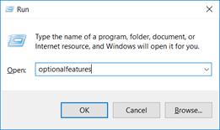

And make sure this “Containers” option is checked off.

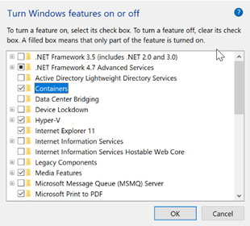

Once that completes, follow these instructions to install docker: <https://docs.docker.com/docker-for-windows/install/>. Grab the**Stable**channel Windows MSI and install it. Once you get it to install, you need to log out and log back in. *NOTE: Although Docker stated it just needed a log-out/log-in, in order for the Docker service to run on my machine it required a reboot.*

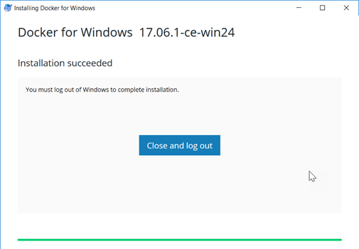

After logging back in, in your notifications, you should get a “Docker is starting…”.

Pull *Official*Kali Linux Docker Image

We will be following the guidance here: <https://www.kali.org/news/official-kali-linux-docker-images/>

Open up your favorite command line interface (CLI). Then type “docker pull kalilinux/kali-rolling”. This will pull the image from the Docker Store.

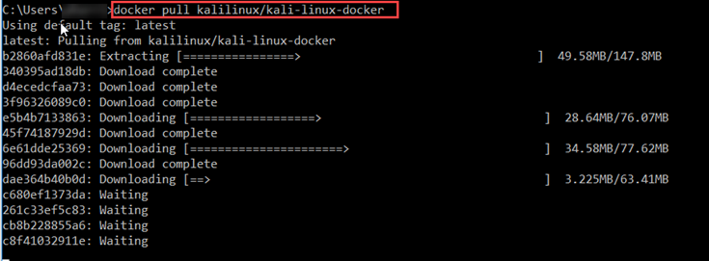

Now, let us enter an interactive bash session with that image by typing “docker run -t -i kalilinux/kali-rolling /bin/bash”



We are now in our fresh install of Kali. Since this install is meant to be the *minimal*, you need to grab the packages you actually care about. This helps keep the image small but does require a good Internet connection to get up and running.

Before installing any package, let’s upgrade our Kali Linux and remove all packages we no longer need via “apt update && apt full-upgrade && apt auto-remove && apt-autoclean”

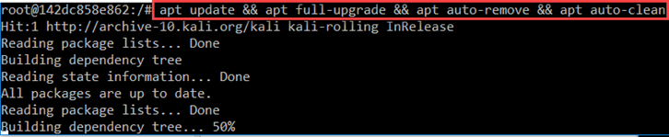

Installing the Metasploit Framework

Lastly, let us install the go-to package for most pentesters… Metasploit. A simple command of “apt install metasploit-framework ruby” will do the trick.

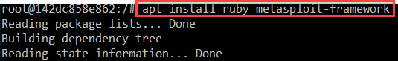

Just start up the PostgresSQL database that Metasploit uses, initialize the database, and to msfconsole we go!

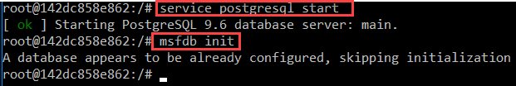

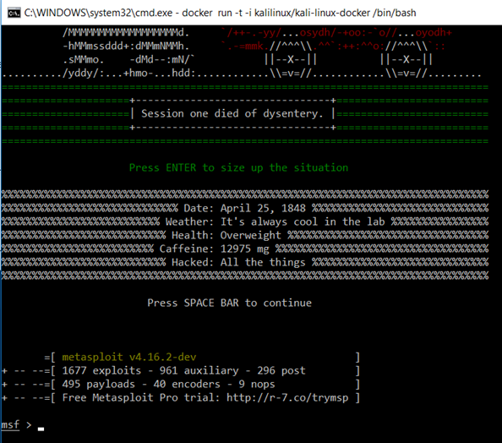

Happy Hunting,